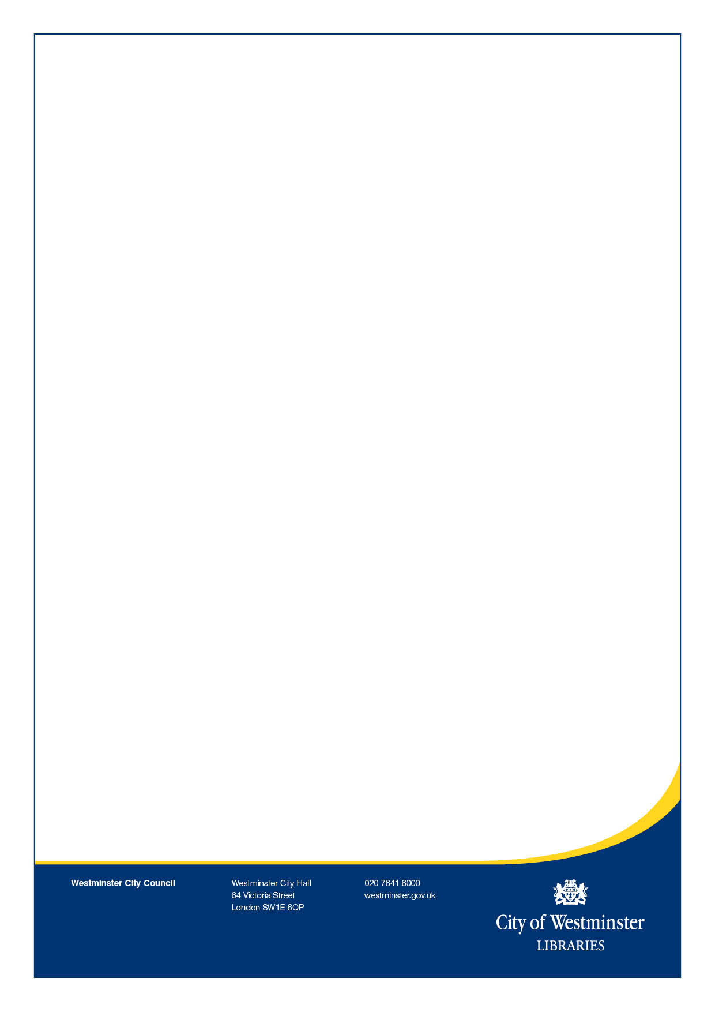

**Just turn up!**

**Everyone welcome!**

Any queries please email: [Mkhan1@westminster.gov.uk](mailto:Mkhan1@westminster.gov.uk)

Paddington Library: 020 7641 6200

**English Conversation Club**

Would you like to speak English with confidence? Then look no further join FREE today!

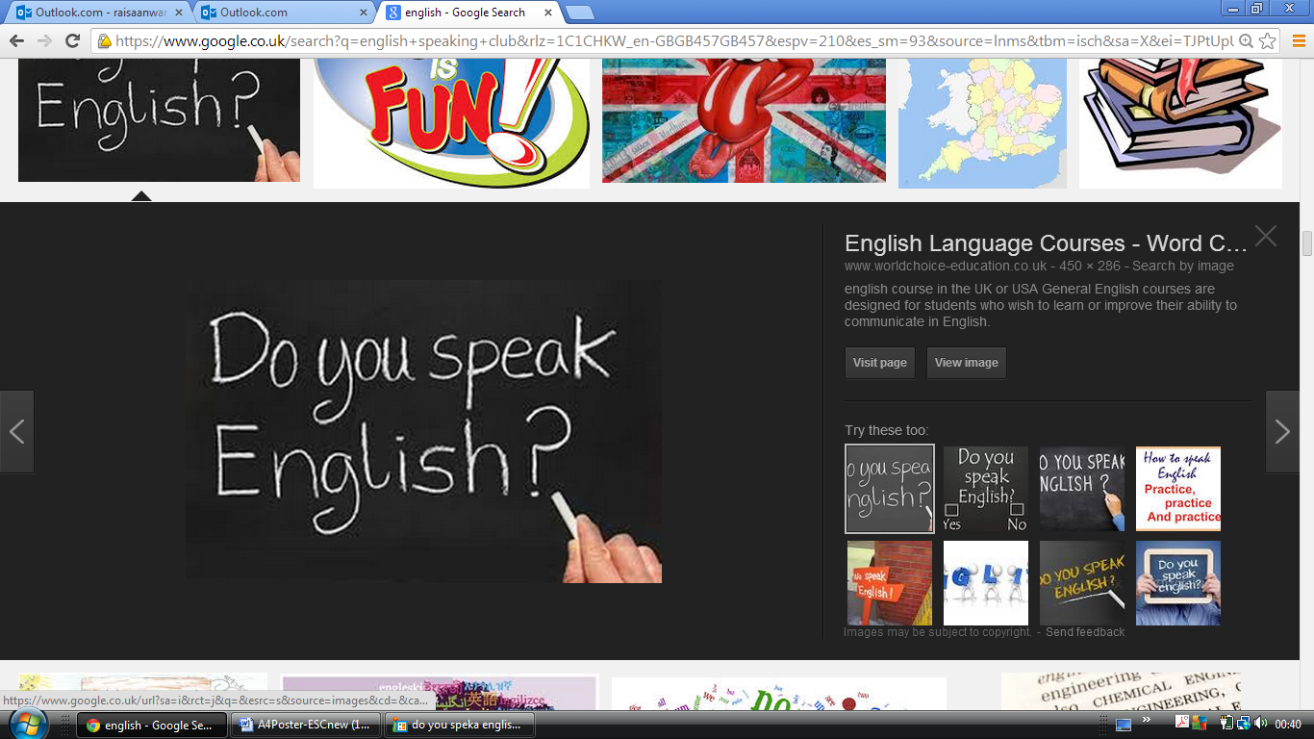

**When:** **Starts on Saturday 29th April**

**11am – 12:30pm**

**Where:** **Paddington Library, 45 Porchester Road**

**London, W2 5DU**

ed at Lower charges for Rescard holders

Late returns charged Lower charges for Rescard holders

Late returns charged at normal rate

at normal rate

normal rate