1 financial at
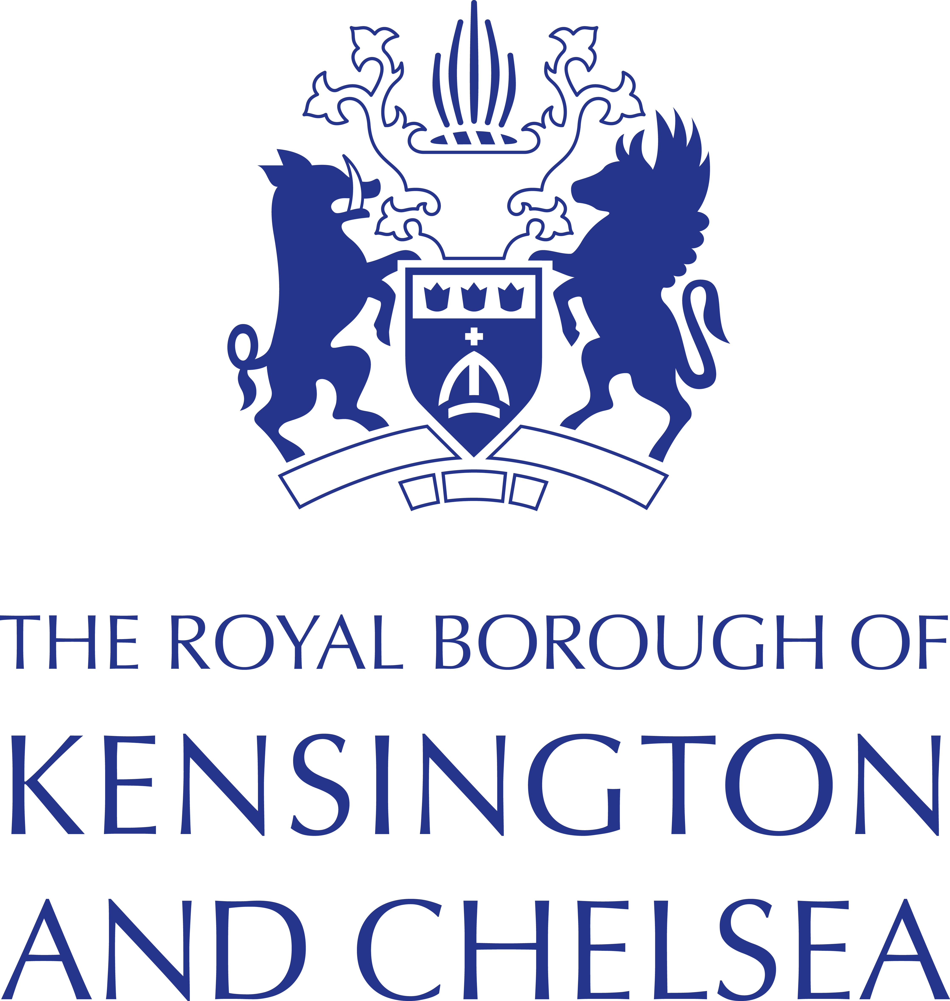
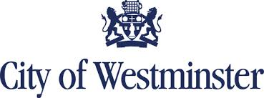

Friday 22 March 2024
Public Health information briefing for Libraries, Leisure, Family Hubs and VCS in Westminster and Kensington and Chelsea

- Free blood pressure checks
A new blood pressure testing campaign launched on Monday 11 March encouraging those aged 40 and over to get a free blood pressure check at the nearest participating pharmacy.
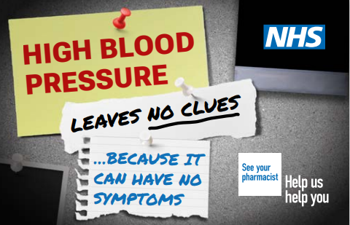

High blood pressure is the largest treatable risk factor for cardiovascular disease (CVD) which can lead to a fatal heart attack, stroke, kidney disease or vascular dementia.

Our ask to you: We enclose some posters to print please and some digital resources for your screens, also please use the resources below as appropriate:
- YouTube video here
- Campaign resource centre for those of you who use it
- Find a pharmacy:

- Measles
The spread of Measles continues to be a priority in North West London. Measles spreads easily and can cause serious illnesses such as pneumonia and meningitis.

Our ask to you:
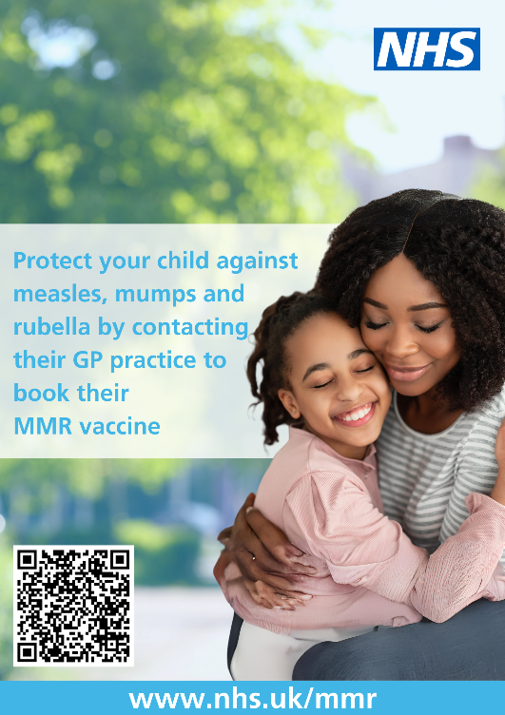
Please display a printable poster (samples above and attached to the email) and please request any MMR posters in other languages ready to print.

Please also promote the following messages in your virtual communications and in person:

- The best way to protect yourself and your family from measles is by having two doses of the MMR vaccine.
- Some MMR vaccines contain porcine gelatine but there is one widely available called Priorix® that is gelatine free. Families who require the gelatine free vaccine can request this from their GP or healthcare provider.
- Call your GP or check your child’s red book to see whether you’ve had both doses of the vaccine.
- If you or your family have symptoms, please stay at home to stop it from spreading, and call your GP or NHS 111.
- Please visit the NHS website for more information.
- Access more information on Measles | Westminster FIS Measles | Royal Borough of Kensington and Chelsea (rbkc.gov.uk)

- Health hub pop up sessions
North West London Integrated Care Board and their roving immunisations teams are asking for our support for their upcoming health hub pop ups.

These teams travel to community locations to deliver immunisations according to local need, and also offer NHS health checks using a conversational ‘Making Every Contact Count Approach.’

Our ask to you:
Please check out the following pages for the latest pop ups. If you would like to promote them we are happy to send you the promotional materials as soon as we receive them. Some of you will already have these thank you.

- Pop-up health hubs | Westminster City Council

- Pop up Health Hubs | Royal Borough of Kensington and Chelsea (rbkc.gov.uk)

- Suicide Prevention campaign – ‘Stay with us’ free training offer
We are offering FREE suicide prevention training this month to everyone who lives and works in Westminster and Kensington & Chelsea.
Find out more and register for the training.

Visit our suicide prevention hubs for Royal Borough of Kensington and Chelsea and Westminster City Council for local services and support.

Our ask to you:
- Help us raise awareness of suicide and its impact on our communities.
- Please sign up to the training and encourage everyone in your teams and networks to sign up for the training as well. Thank you.

- Making Every Contact Count (MECC) free training from the One You service
Core MECC
Free one-hour MECC webinars and two-hour training is available for anyone who comes into contact with the public in their job and has the opportunity to have a healthy conversation with them on issues that affect their wellbeing.
The training covers how to give support in the best way possible through listening and respectful and effective signposting.

MECC for Suicide Prevention
Making Every Contact Count Training will help you engage with people who might be having suicidal thoughts.

Our ask to you:
- Please share the links for Core MECC and Suicide Prevention MECC with contact details in your communications and newsletters.
- Please contact Baron.Ibrahim@thrivetribe.org.uk for more details of all the sessions and to register.
- Eventbrite link for future Open and Suicide Prevention sessions until end of June is here

Further information
Please contact Kate Gielgud at kgielgud@westminster.gov.uk if you have any questions or would like further information on any of the above.

